**Module - 3**

Q1)What is RDBMS

* The software used to store, manage, query, and retrieve data stored in a relational database is called a relational database management system (RDBMS)

Q2)What is SQL

* Structured query language (SQL) is a programming language for storing and processing information in a relational database.

Q3)Write SQL Commands

DDL(Data Definition Language), DML(Data Manipulation Language), DQL(Data Query Language), TCL(Transaction Control Language), DCL(Data Control Language).

Q4)What is join

* The SQL JOIN is a command clause that combines records from two or more tables in a database. It is a means of combining data in fields from two tables by using values common to each table.

Q5)Write Types of join

* (INNER) JOIN : Returns records that have matching values in both tables.
* LEFT (OUTER) JOIN : Returns all records from the left table, and the matched records from the right table.
* RIGHT (OUTER) JOIN : Returns all records from the right table, and the matched records from the left table.

Q6)How many comstraint and describe it self

* Primary Key
* Foreign Key
* Default
* Unique
* Check
* Not Null

Q7)Difference Between DBMS And RDBMS

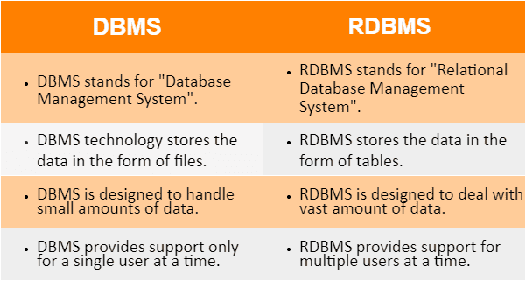

Q8)What is API Testing

* API testing is a type of software testing that analyzes an application program interface (API) to verify that it fulfills its expected functionality, security, performance and reliability.

Q9) Types of API Testing

* Validation testing
* Functional testing
* Load testing
* Reliability testing
* Security testing
* Penetration testing
* Fuzz testing
* Unit testing

Q10)What is responsive testing

* Responsive testing involves how a website or web application looks and behaves on different devices, screen sizes, and resolutions.

Q11) Types of Tools for Responsive Testing

* BrowserStack
* Cross Browser Testing
* Selenium
* Lamda Test

Q12)Full Form of Ipa , apk

* IPA - IOs Package App Store
* APK - Application Package File

Q13)Write Steps To Open Developer Options Mode ON

* Go to "Settings"
* Tap "About device" or "About phone" Tap “Software information”
* Tap “Build number” seven times
* Enter your pattern, PIN or password to enable the Developer options menu.
* The "Developer options" menu will now appear in your Settings menu.